**FOUND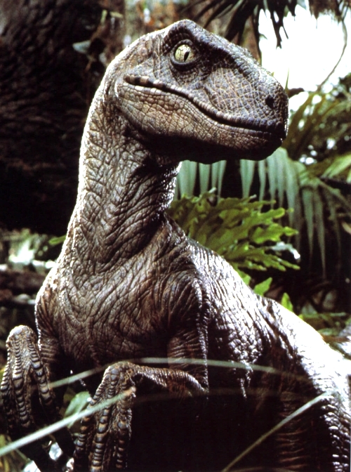 - 5ft tall velociraptor**

**- Very *bitey***

**- May have come from a bad home**

**- He doesn’t answer to ANYTHING  
- HE IS VERY ANGRY**

**PLEASE COME PICK HIM UP IMMEDIATELY**

Email: found_flyer@dontstopbeingawesome.com